# How to use a historic map image in Knight Lab’s StoryMapJS

This guide will take you through how to use a historic map image in Knight Lab’s StoryMap JS. You’ll need to start with a TIFF image. If your image is in another file format like a PDF, JPEG/JPG, or PNG, you might need to convert it into a TIFF first (some versions of QGIS can import PDFs just fine). You can convert a PDF to a TIFF image in Adobe Acrobat Pro, available to students on lab, classroom, and library computers. Most image editors will let you convert another image format, like a JPEG/JPG or PNG, into a TIFF using the “Save as...” option.

This guide has screen captures and moving gifs -- you should be able to make all images bigger if they’re too small to see, just select and resize using the boxes in the corners of the selected image. Gifs have a dotted border. Use the contents bookmarks to the left to navigate to specific sections as needed.

Please let me know if you have any questions - you can shoot me an email at [ejklein@uncg.edu](mailto:ejklein@uncg.edu).

Jo

## Guides & Tutorials (for more help):

* [QGIS v3.10 Guide](https://docs.qgis.org/3.10/en/docs/)
* [Mapbox help](https://docs.mapbox.com/help/)
* [Knight Lab help desk](https://knightlab.zendesk.com/hc/en-us)

## QGIS (v3.10): Georeference your TIFF image:

In this set of steps, you’ll upload your TIFF map image into QGIS and match spots on your image with coordinates that correspond to their real-world locations. If you’re using an image that doesn’t correspond with the real world, you’ll need to follow a different set of steps. Contact Jo at [ejklein@uncg.edu](mailto:ejklein@uncg.edu) for more help with this!

### Set up your workspace

1. Download and install QGIS (I’m using v3.10 but the steps are similar for other versions)
2. Open a new project
3. Set the project CRS to an appropriate CRS for the region you’re looking at (WGS 84: EPSG 4326 is common, EPSG 3857 is a “Pseudo-Mercator” projection and is what sites like Google Maps use. Since you’re going to be using base maps that use EPSG 3857, go ahead and use this instead of 4326).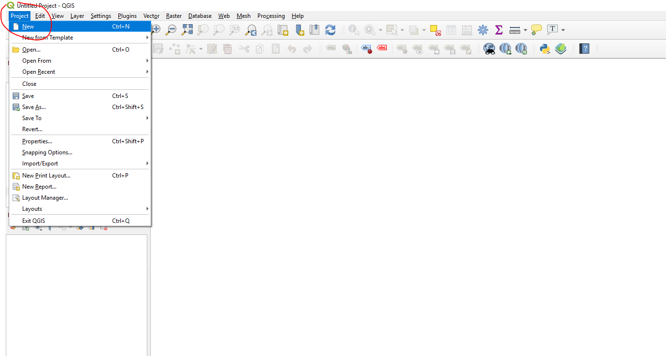
4. Enable “on the fly transformation” if you’re using an older version of QGIS (not pictured, it would be a checkbox at the top)
5. Save your project file to a write-able folder

### Add a basemap

#### Option A (OpenStreetMap or OSM):

1. Select *OpenStreetMap* under *XYZ Tiles* in the Browser

#### Option B (more maps, including Google, Apple, Bing, Mapbox, and others):

1. Enable the *QuickMapServices* plugin
2. Get extra maps via *contributed pack*

### Add and georeference your TIFF image

Georeferenced TIFF images are sometimes called “GeoTIFF,” but will have the same .tif file extension as a regular TIFF image. If you load your TIFF into QGIS (see [QGIS Documentation: 5.3. Sample Session: Loading raster and vector layers](https://docs.qgis.org/3.10/en/docs/user_manual/introduction/getting_started.html#sample-session-loading-raster-and-vector-layers) for help with this) and it gives you an error message or isn’t located in the right place, you’ll need to georeference it.

* If it is already georeferenced and loads in the correct location on the map, you can skip to *Add your Georeferenced Image to Mapbox*.
* If it isn’t, continue with the steps below:

1. Enable the *Georeferencer GDAL* plugin (same procedure as with the QuickMapServices plugin)
2. Open the *Georeferencer* tool

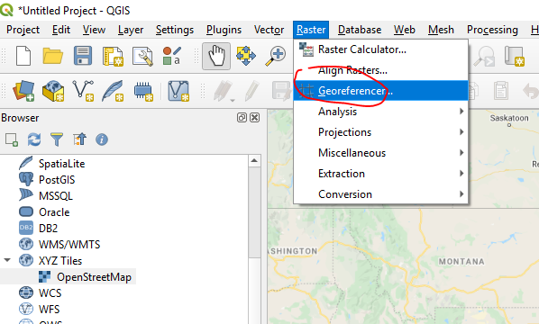

1. Add your image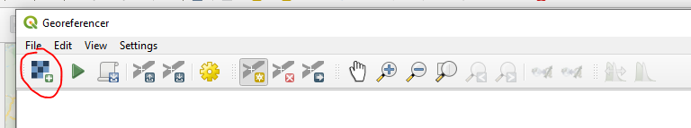
2. Set *Transformation Settings.* The file name and folder you choose here will be the name of your georeferenced file, as well as its location, after you run the georeferencer tool. Remember it!**
3. Add at least three *GCP points* using the canvas or coordinates. Go for the four corners and a spot in the middle, for the best results. A large number, say higher than 10, may skew it too much. The red lines that appear over your GCP points after three points denotes “error” -- i.e. how much skewing will need to be done! I eyeballed these in the example, but you could go either more or less detailed than I did! Beware of using rivers as landmarks unless you’re sure they haven’t changed -- rivers and streams change a lot! The Broad River is unrecognizable on this example map.



1. Save your GCP points to the same location as your project and historic image (optional, but it helps find things, and these will help you if you need to change anything!) You can also load GCP points that you’ve saved before.

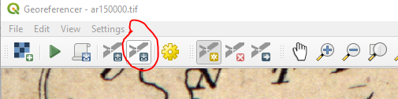

1. Run the georeferencer and check the new layer against your basemap (you can do this by making your layers transparent in the layer properties). Note that geography can change! Rivers move, land erodes. You may not be able to get a perfect match.

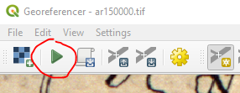

1. Your file is ready to be added to Mapbox! It will be in the location you specified earlier, and usually has “modified” at the end of the filename unless you renamed it something else. You can proceed to the next step and add your new GeoTIFF to Mapbox, OR you can create a shapefile for data and markers if you’d like (see below).

### Add data and markers to your map (optional)

Adding data to your map in QGIS can help in two main ways:

* You can import your data into Mapbox and add stylized markers that will show up on your basemap (note: you can’t interact with these markers in StoryMapJS).
* You can import your data into Google Maps all at once to make a summary map to display next to your StoryMap!

To do this:

1. Create a new “vector” layer (vector refers to points, lines, or polygons/shapes that are laid over the basemap/raster image. Rasters are pixels, vectors are points or lines, essentially).
2. Give your layer a name, and add some fields. Here’s where you can add date fields or other descriptors. You can also add these later if you forget one. **You have to click the “...” and specify the file location** or else it won’t make the file and you’ll get a permission error. Use the same CRS as before, since you’ll be clicking on the basemap to make points.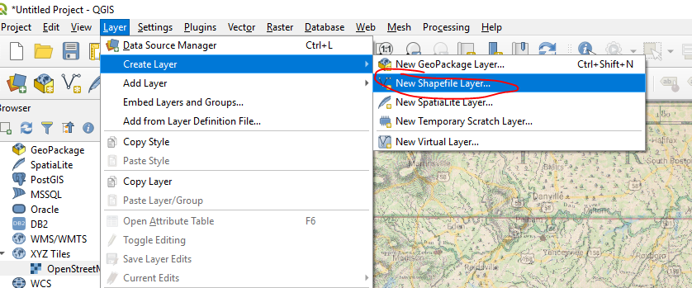
3. Add a point to your layer and give it some data!
4. Save your changes, then locate your shapefile files. If you forget where you saved them to in the previous steps, right click on the shapefile layer in QGIS, then click on Properties and navigate to the *Information* section. The *Path* is the location of your file and filename. Shapefiles are 5 or 6 files with the same name and different file extensions, like .shp, .dbf, etc. We need all of these in the same folder!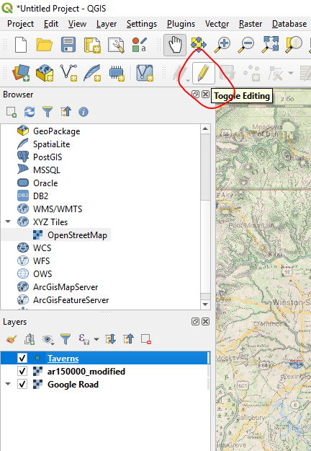
5. Zip your shapefile files into a zipped folder (right-click, add to zipped folder. This will look different depending on what programs you have installed -- I use 7-zip. On Mac computers, this probably says “Compress 5 files”). They will be added to Mapbox separately from your map image.

Now you’re ready to add stuff to Mapbox!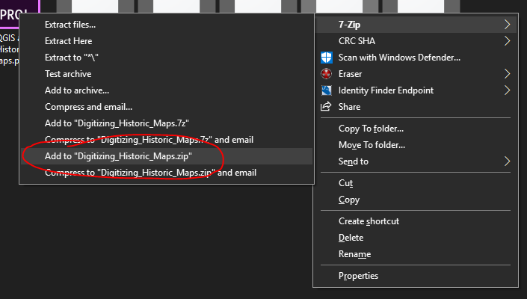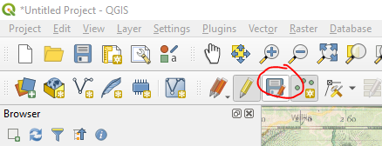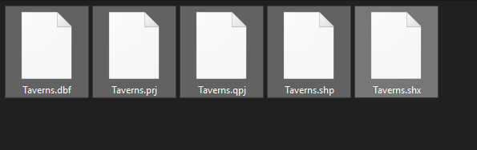

## Mapbox: Convert your georeferenced image to tiles and get it online

In this second set of steps, you’ll create a new blank map in Mapbox Studio, upload your map image (and your other data shapefile if you made one), and then publish it so you can upload it to KnightLab’s StoryMap. This step is necessary because it converts your geoTIFF to a tileset of tiles, and then hosts them online on Mapbox’s servers. Tiles are what online web maps like Google and Apple Maps, and KnightLab’s StoryMap, use. They let the website load the map quickly, one square tile at a time, so that when you zoom in or pan around on the map it’s a smooth and quick transition. There are other methods of converting TIFFs into tiles and then hosting them on servers online, but Mapbox does this for free! And Mapbox also supports QGIS, so their tutorial guides and documentation can help if you georeferenced your map in QGIS.

### Open Mapbox Studio

1. Create an account & login to [Mapbox.com](http://mapbox.com)
2. Click on your profile picture in the upper right once you’ve logged in (as of 3/30/2020), then click on *Studio* to open Mapbox Studio (you can also access it using [studio.mapbox.com](http://studio.mapbox.com))

### Create a new blank map

1. Click on *New style* to create your map.
2. Select *Blank,* then click on *Customize Blank* to go to the map editor.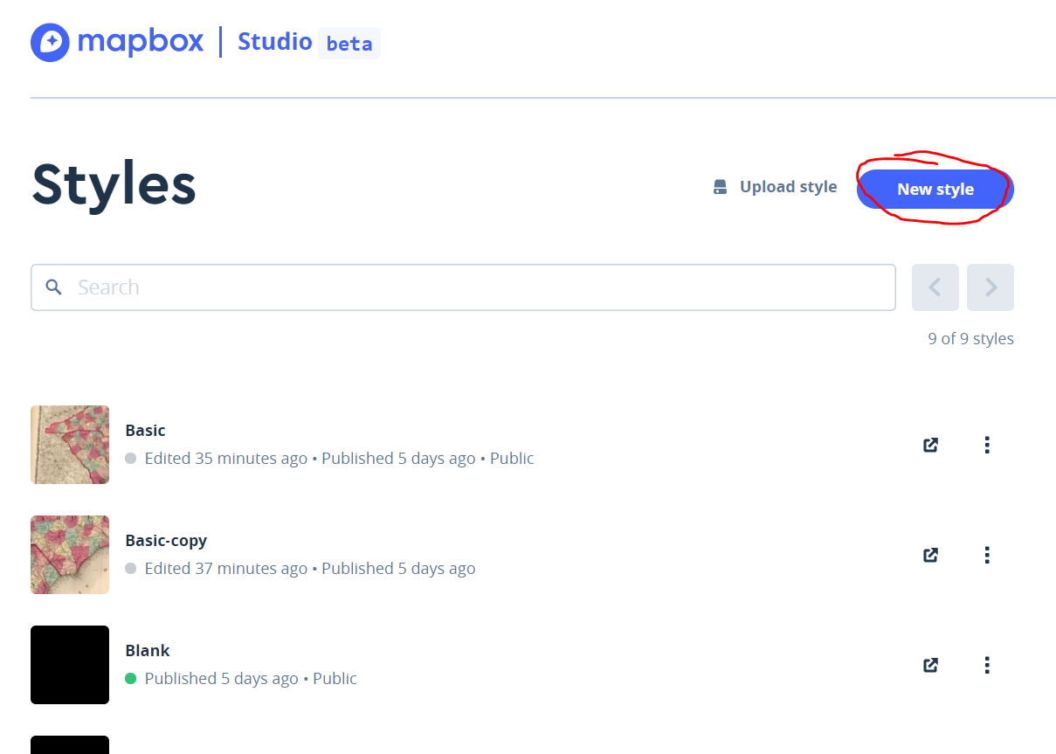
3. You can rename your map by clicking on the title, which should say *Blank*. This is optional but makes it easier to find stuff later.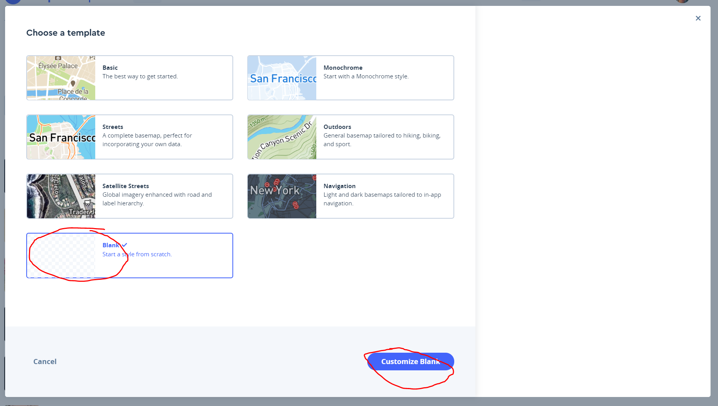

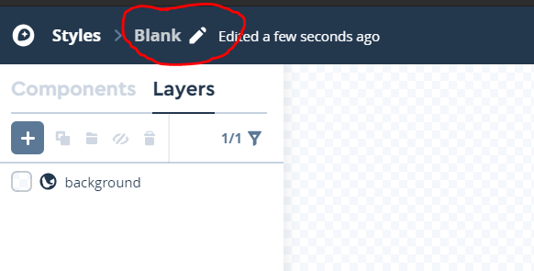

### Add your georeferenced image

Now we need to double check to make sure your georeferenced map image is in the right spot! This step is optional, but will make troubleshooting easier if you run into a problem later.

1. Click the plus sign in the *Layers* tab to open the new layer menu. You can also just press the “n” key on most computers.
2. Under the *Select data* tab, click on *Upload data* and then on *Select a file* in the popup. You may need to disable your popup blocker for this page if the popup won’t appear.



1. Select your georeferenced map image, then click *Open* (it might say something else on a Mac, like “select”), then *Confirm.* You’ll see a progress bar or percentage in the lower right corner of the window. After it finishes, it’ll give you a “completed” message. This means your map has been uploaded and converted into a tileset! **Your map image will not be loaded onto the map window yet.**
2. Under *Unused sources*, scroll down until you see the file you just uploaded. Click it to expand the drop down menu, then click the revealed tileset to add it to your map. It may look odd - that’s OK! Zoom in to make sure it’s still the right resolution when you zoom in. If it’s blurry, you may need to pick a higher resolution map image. Close the new layer menu, and admire your uploaded map on a transparent checkered background.

### Double-check your map image

1. Add another new layer, but this time under *Select data,* under *Unused sources,* select *Mapbox Satellite* instead of your file*.* Click on it to expand the drop down as before, and click the tileset to add it to your map. It will look very weird -- close the new layer menu, and it will look less weird!

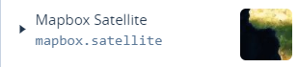

1. You may need to rearrange your map layers. Hover over a map layer in the *Layers* tab until you see three horizontal lines appear. Select that lines icon, and click and drag to move your layer to the top of the list. It should appear on top of the world satellite map. 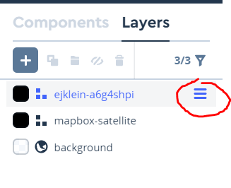
2. Check that your map image is located on the world map where it’s supposed to be. Zoom in or out if necessary. If it’s in the right spot, delete the *Mapbox Satellite* layer by selecting the layer in the *Layers* tab and then clicking on the trash can symbol above the listed layers. If it’s not in the right spot, then your image was not georeferenced properly. There are a number of reasons why this may be -- contact Jo if you need help troubleshooting!

### Add shapefiles for data points (optional)

This follows the same procedure as adding a map image, but you’ll select your zipped/compressed folder (with the 5-6 shapefile files) instead. Don’t forget to click on the uploaded data to add it to your map! You can customize the data markers on your map in the *styles* tab:

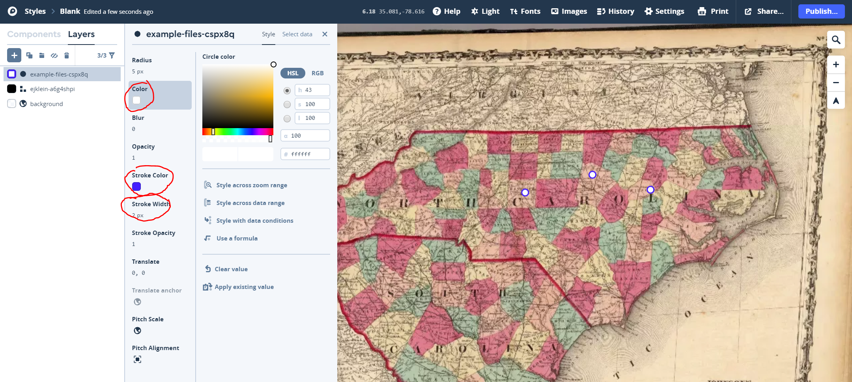

*Radius* changes the size of the marker

*Color* changes the color of your marker

*Stroke Color* changes the color of the marker’s border

*Stroke Width* changes the width/thickness of the marker’s border

You can also add labels and text, but that’s an advanced step. Contact Jo if you’d like to do that, or consult Mapbox’s help guides (linked at the beginning of this guide).

### Publish and share your map tiles

1. When your map looks how you want it, click on *Publish* in the upper right corner, then *Publish* again in the popup that appears. This will publish the tileset and other layers on your map to Mapbox’s servers as a “style.”

After you upload your map style to Knight Lab’s StoryMap, you can edit your map in Mapbox, then click *Publish* to update the map in your StoryMap without having to do anything else! You can also *Publish as New* if you’re making another StoryMap later and don’t want to edit the old one -- that will create a copy of your map. Right now it doesn’t matter which one you pick, but note that creating a copy can make it hard to figure out which one you’ve used in your StoryMap!

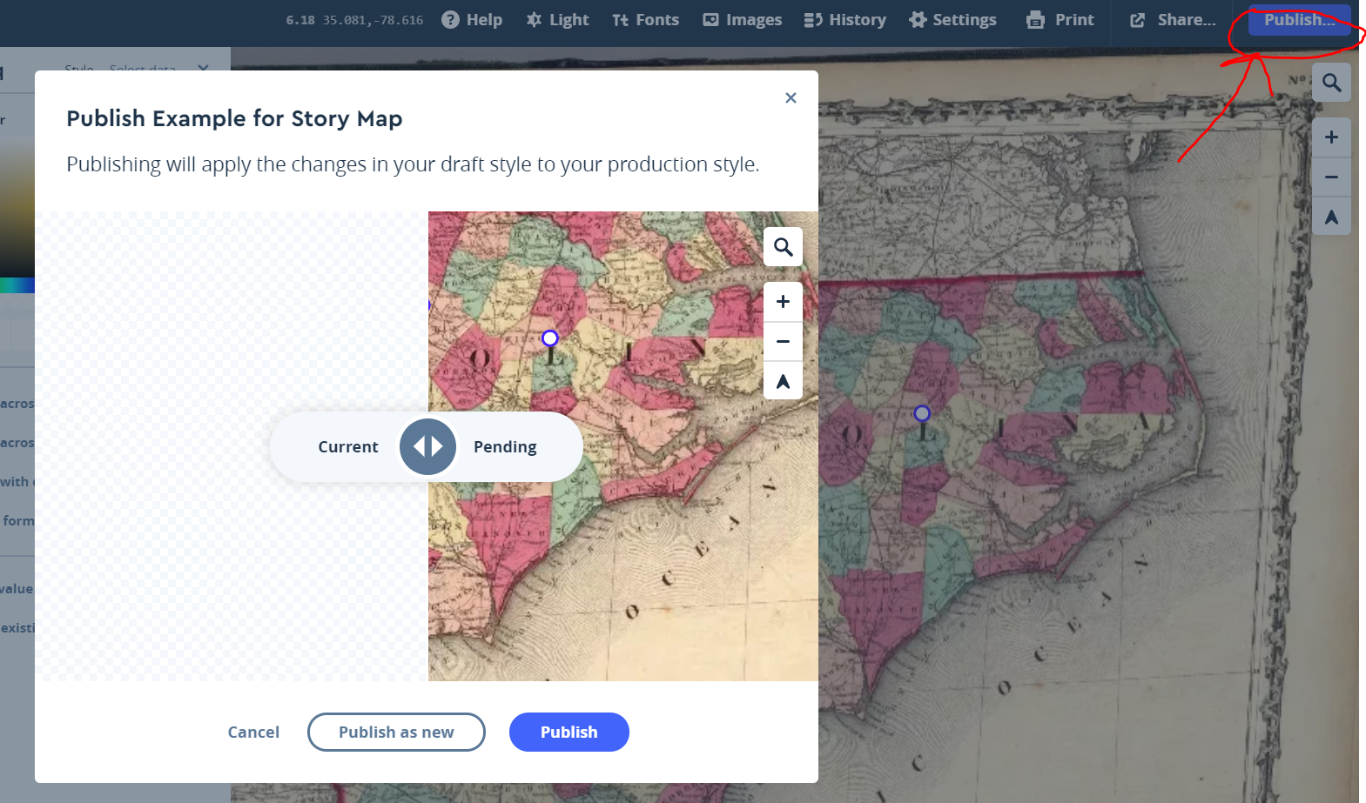

1. Next click on *Share*, to the left of *Publish,* and then click *Make public.* This step will let StoryMap access your map/style using its Style URL and Access token (1 and 2 under *Developer resources).* Keep this page open or copy the Style URL and Access token to a notepad file or word document -- you’ll need them later!

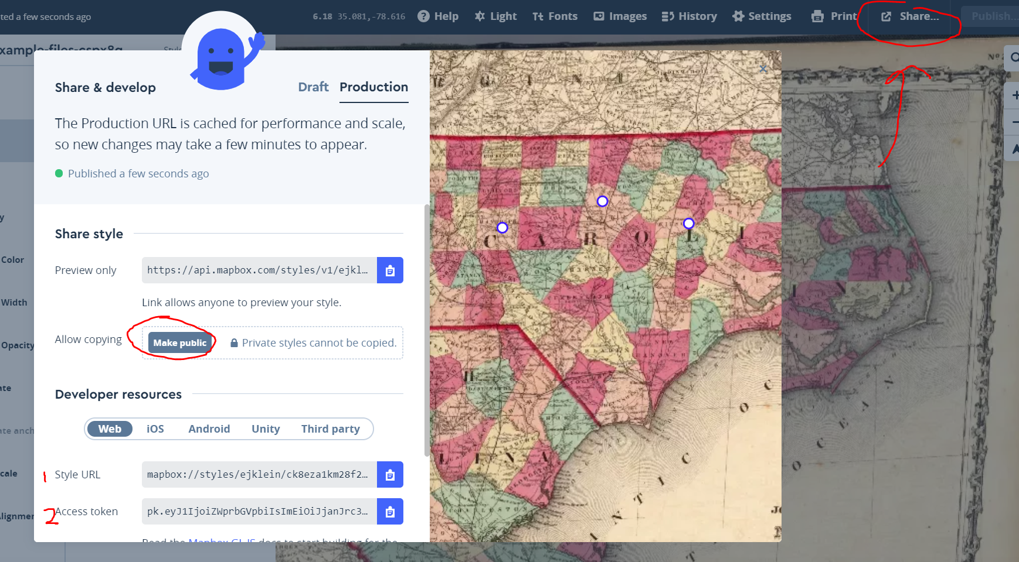

## Knight Lab’s StoryMap: Upload your map into your story map and start adding data!

In this third and final set of steps, you’ll load your Mapbox style into Knight Lab’s StoryMap tool, and customize markers in an optional step.

### Open Knight Lab’s StoryMap

1. Click on the *Make a StoryMap* button at <https://storymap.knightlab.com/> and login using your google account.

**Note:** you can use your UNCG login, but you will not have access to it after you leave UNCG. If you want to still be able to edit your story map in the future, use a different gmail account!

1. Create a new map, and give it a name. Click *Create.*

### Connect your map style from Mapbox

1. When your new map loads, click on *Options* in the upper left to open the options menu. In the *Display* tab, under *Map Type* at the bottom, select *Mapbox* in the dropdown menu.
2. Copy-paste over your Style URL and Access token from Mapbox.

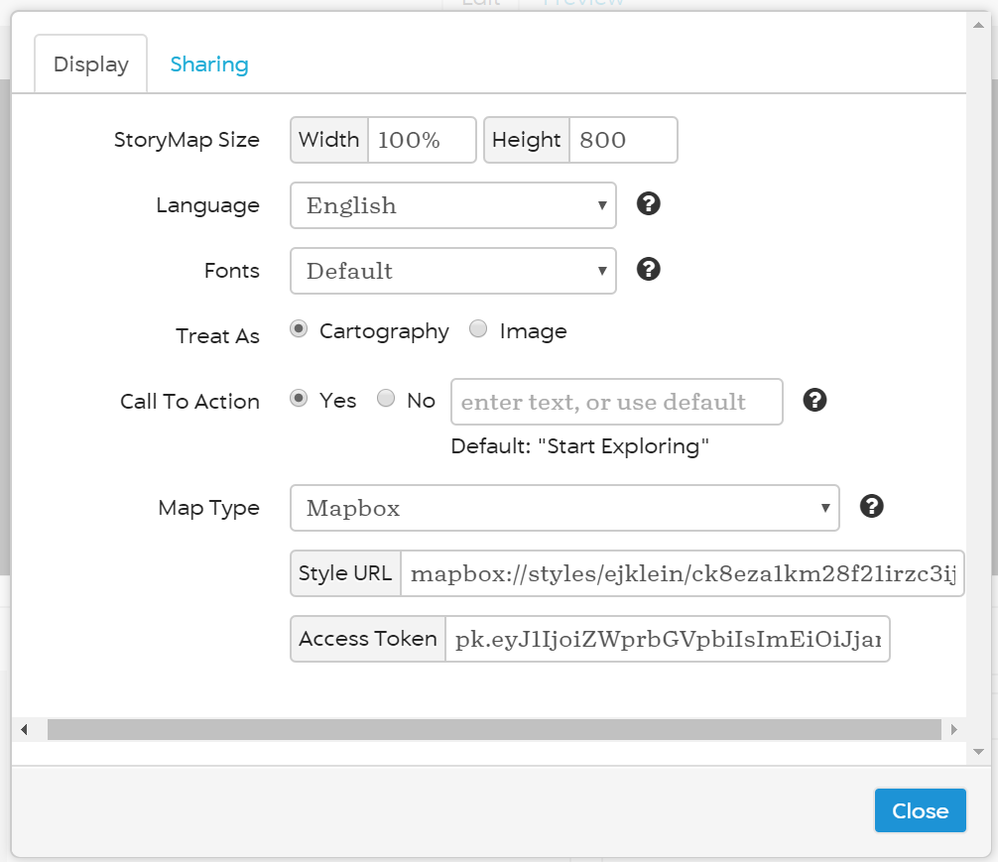

1. Close the menu -- your map may look funky, don’t worry!

### Add your slides & select data points

1. Click on *Add Slide* to the left of the map. If you have coordinates from Google Maps or another source, enter them in the red box. If not, zoom in on your map and click on a point to add it. My example is super tiny! You can also double-click to add a point and then click-and-drag it to where it needs to go.

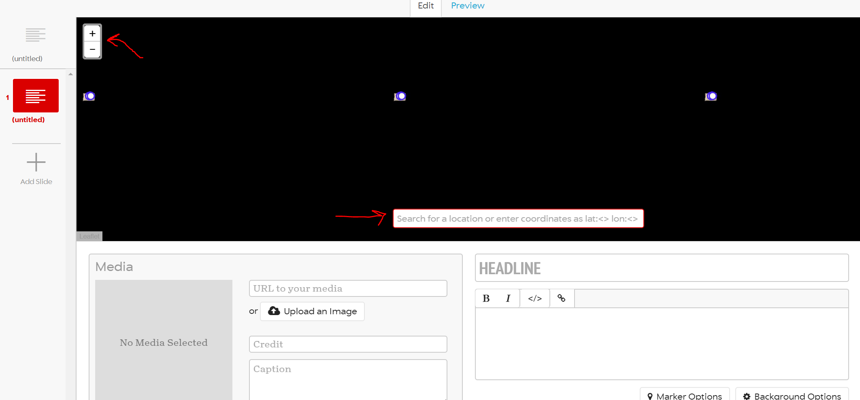

1. You can also edit other things and give your slide a headline, a description, and images or media (like Youtube videos) to go along with your map. Don’t forget to hit save (at the top) after editing! Use “Marker Options” to change your markers to an image. Most images should work, but should have a transparent background. PNG images work best. There’s also a way to do custom markers in Mapbox, if you’d prefer more ability to edit. Contact Jo if you’re interested in this, as it involves a little programming.

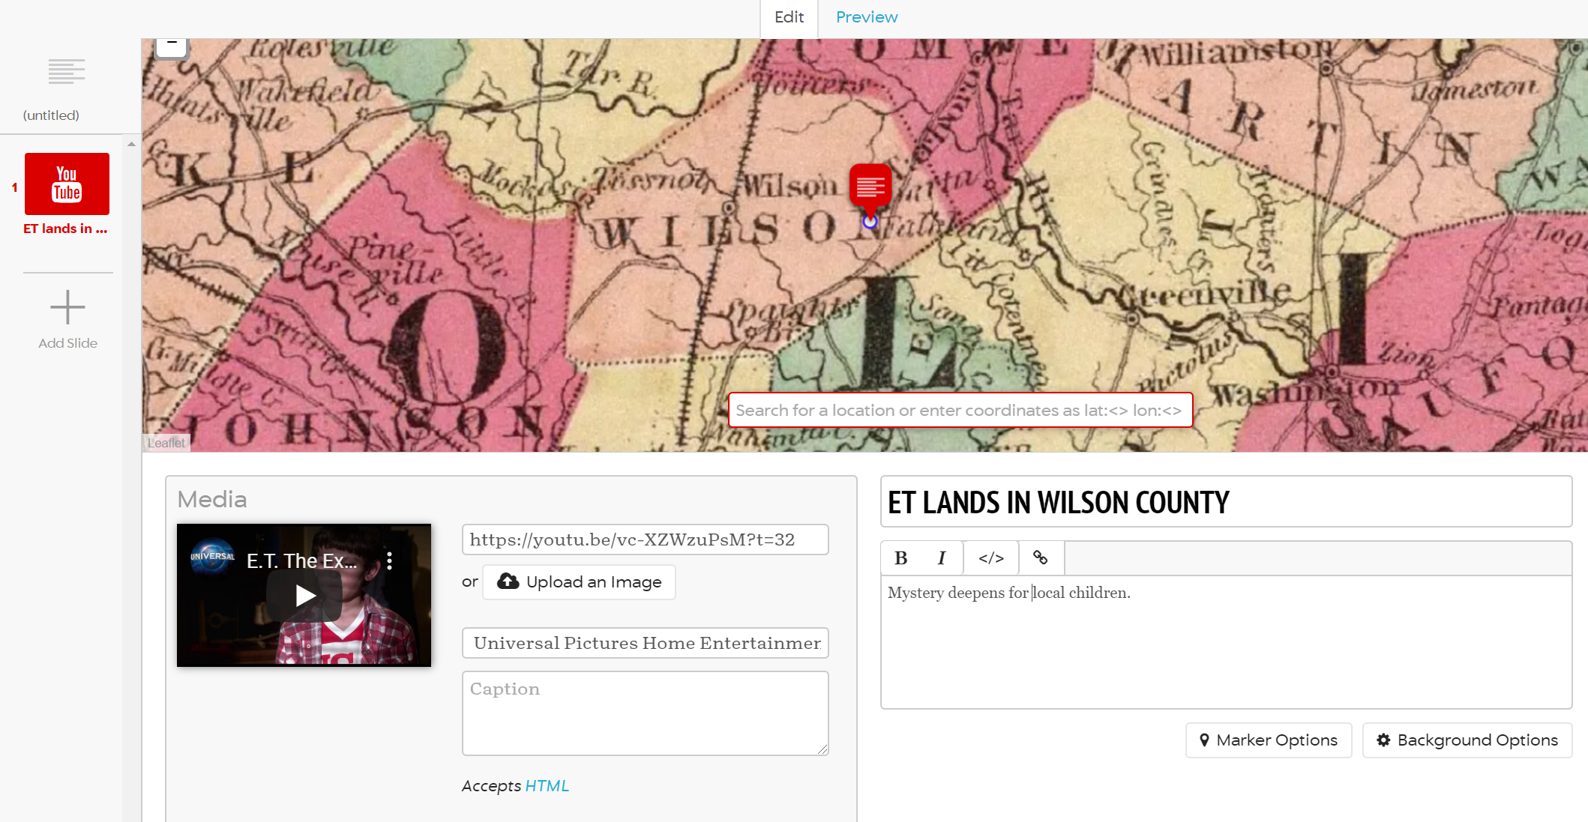

1. If you preview your map, it may look blurry. Give it a little time to load and check back later. If still blurry, try adding a second slide. Just a bug with zooming that sometimes happens.
2. Finish up your StoryMap and publish it! You can share it on social media, share the link to the StoryMap (or link to it in a blog post), or embed it either on sites that use Embedly (like Medium.com) or using iframe code. If you’re using Wordpress, this may not work depending on your site privileges. Jo can help with workarounds if you’re stuck on how to share it.

[Here’s my example StoryMap](https://uploads.knightlab.com/storymapjs/720aea0a739dc5c2028be2c0e5125777/example-storymap-for-custom-historical-images/index.html)